Create a new environment – Anaconda Navigator

1. Click **create**
2. Enter Environment name
3. Click Create

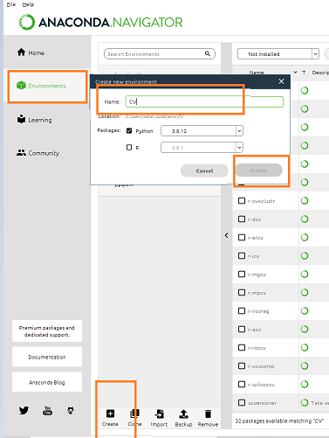

The new environment is ready now

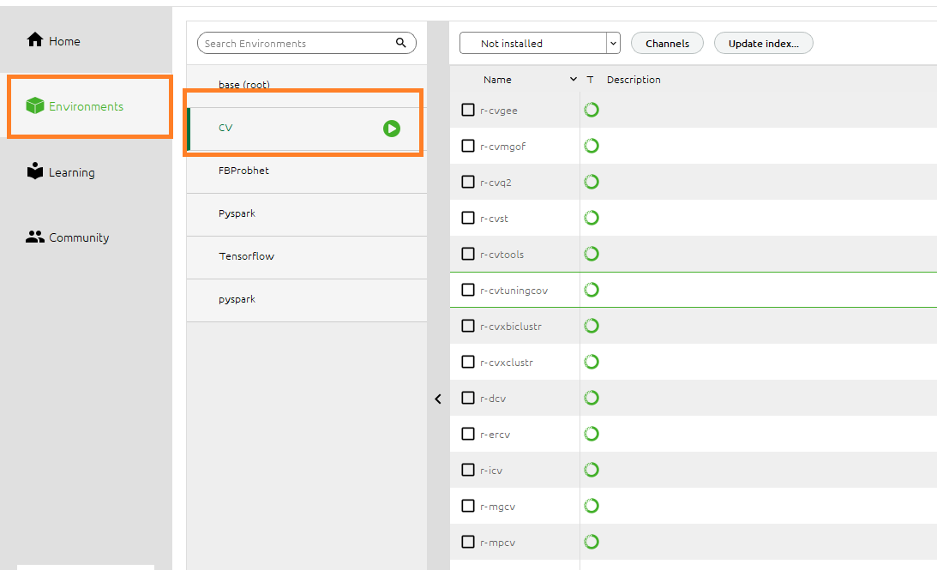

Open Anaconda Navigator –

* Check NumPy, Pandas, Matplotlib, Seaborn under environment CV

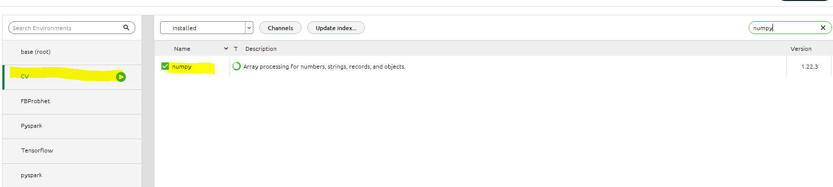

Install Numpy

Search Numpy in the not installed list , Select Numpy , then click – Apply

Install Pandas

Select Pandas, click – Apply

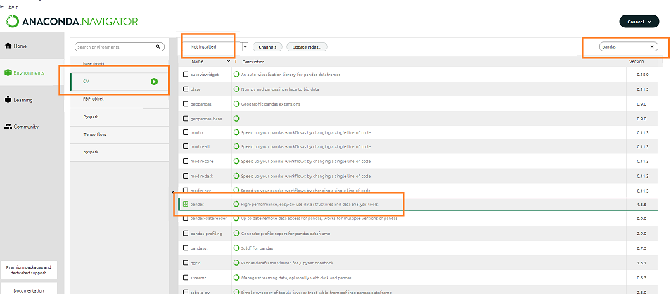

Next Screen Click – Apply

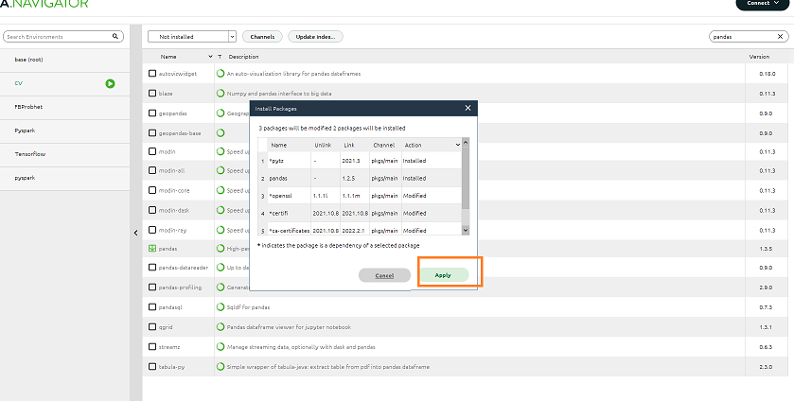

Install Matplotlib

Select Matplotlib click – Apply

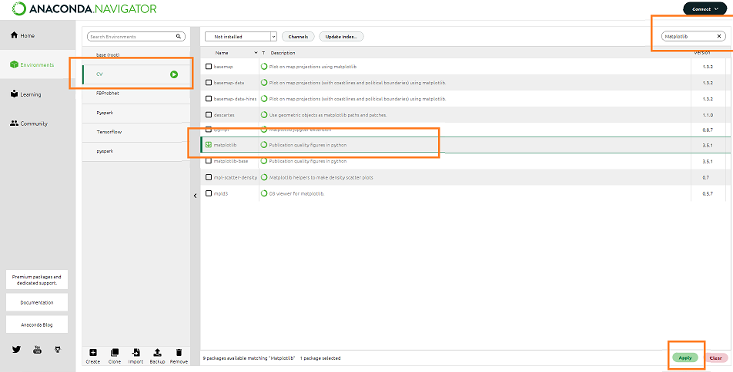

Next Screen Click – Apply

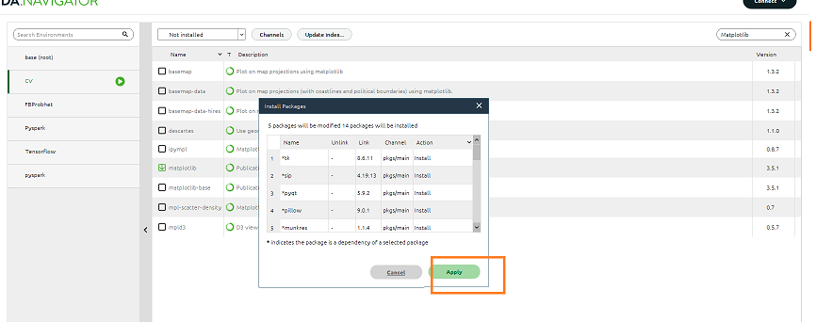

Install Seaborn

Select Seaborn click – Apply

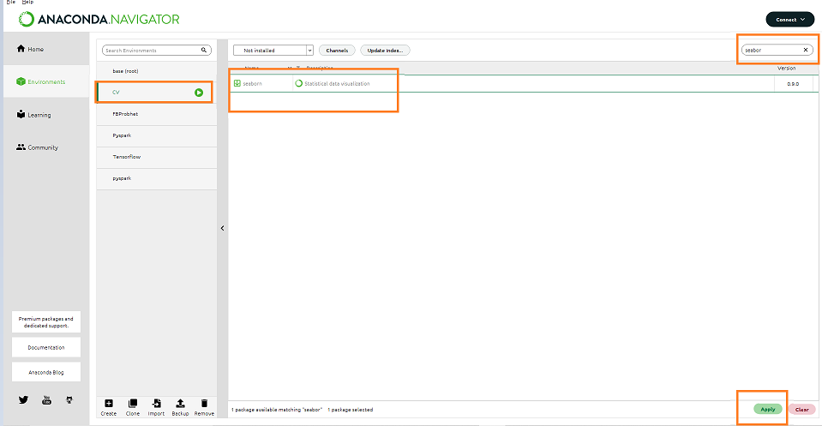

Next Screen Click – Apply

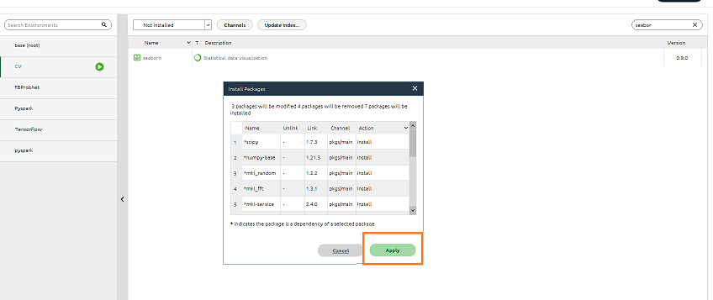

List all environments in Anaconda Prompt

conda env list

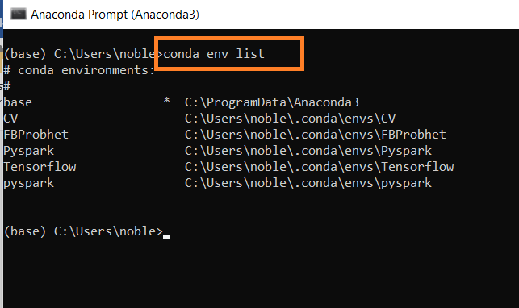

Activate new environment – CV

activate CV

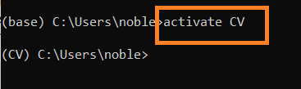

Once CV environment is active – Install open CV

conda install -c conda-forge opencv

pip install opencv-python

pip install opencv-contrib-python

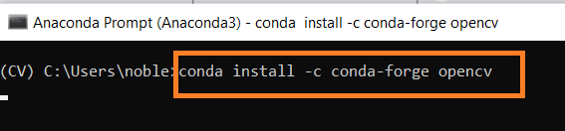

Type y and press enter to proceed

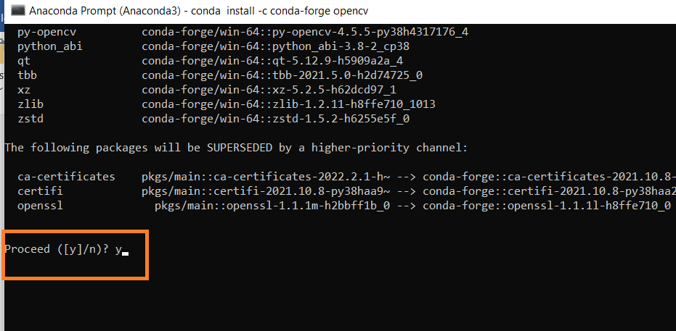

Open CV Install complete

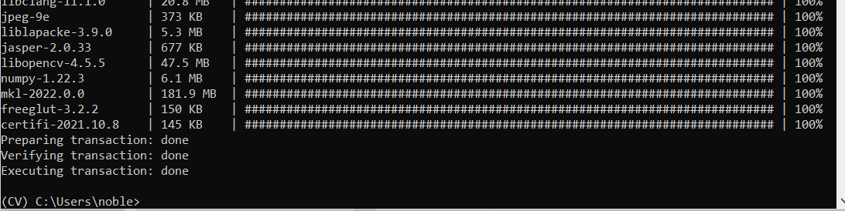

Same way install the following in Anaconda Prompt





Install dlib

Install DLIB

Type in the command prompt of CV

conda install -c conda-forge dlib



Proceed Y/N - > Type Y

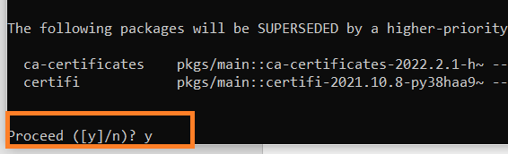

Upgrade/Install Pillow –

This is to avoid any matplotlib error

pip install --upgrade Pillow

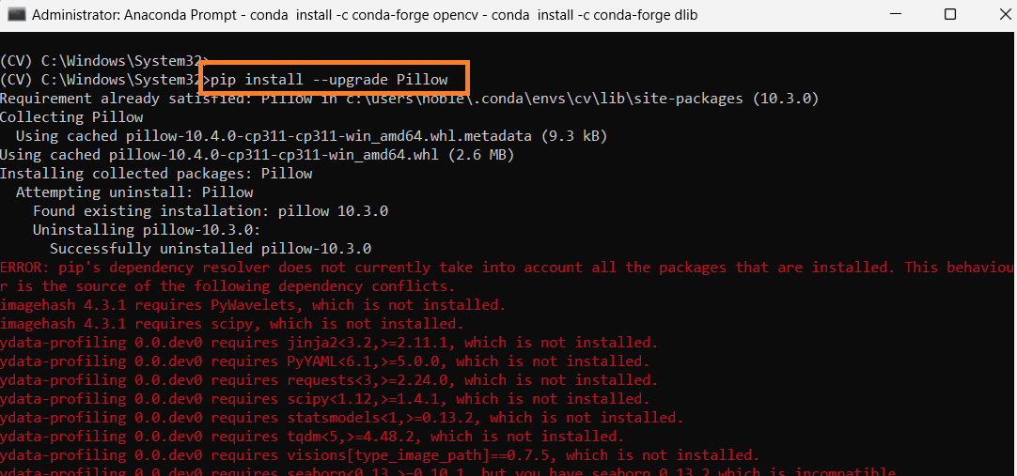

Open Anaconda Navigator –

* Select the new environment -CV
* Click Install Button Jupyter notebook
* Once installation is complete click the Launch Button to open the jupyter notebook

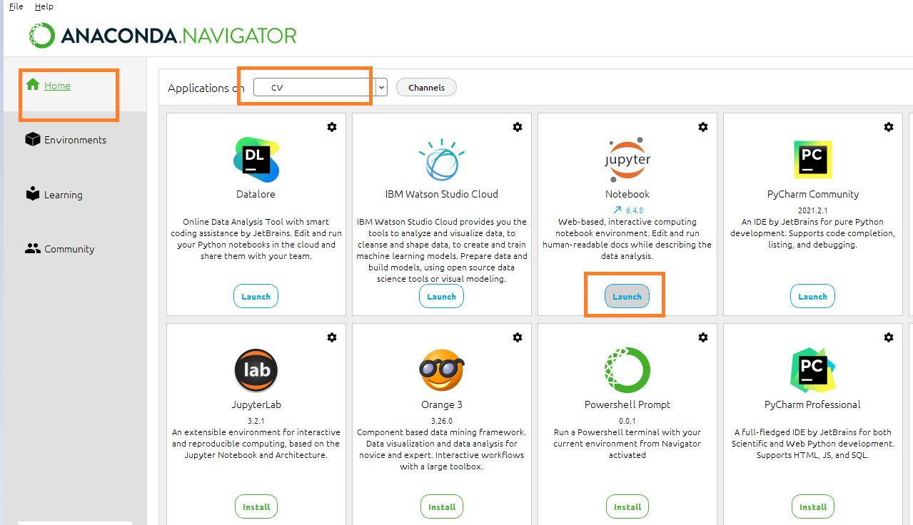

Open a new notebook type

import cv2

import numpy as np

import pandas as pd

import matplotlib.pyplot as plt

import seaborn as sns

import dlib

The statement is completed without any error

